**IMAGE RECOGNISATION USING IBM CLOUD VISUAL RECOGNISATION**

**INTRODUCTION :**

**IBM Watson Visual Recognition is a service provided by IBM Cloud that allows you to analyze and classify images using deep learning algorithms. It can identify scenes, objects, faces, and other visual elements within an image.**

**OBJECTIVE:**

**To develop an automated image recognition system using IBM Watson Visual Recognition to classify food items in images, supporting dietary analysis and meal tracking applications.**

1. **Image Classification: Utilize IBM Watson Visual Recognition to accurately classify food items within images, assigning relevant labels or categories.**
2. **Model Training and Refinement: Train and refine the image classification model by providing a diverse dataset of food images, ensuring the model can accurately identify various types of food.**
3. **Integration: Integrate the trained model into a mobile application, allowing users to capture images of their meals and receive real-time classification results.**

**IMAGE RECOGNISATION :**

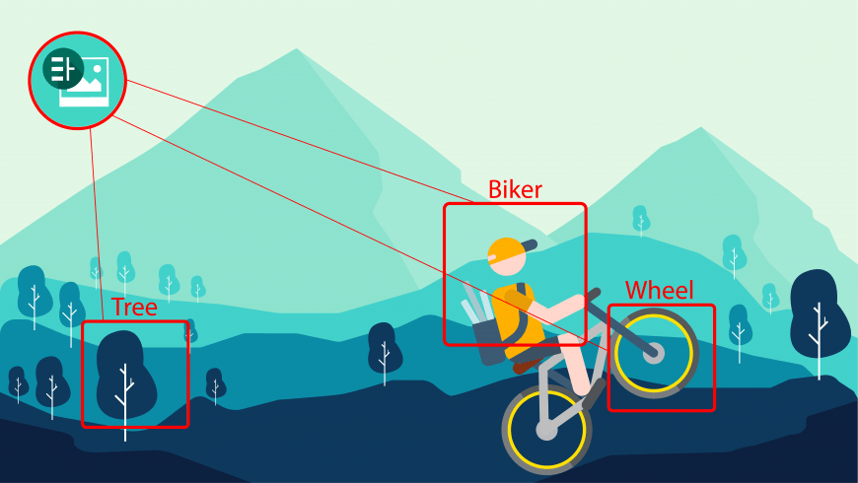

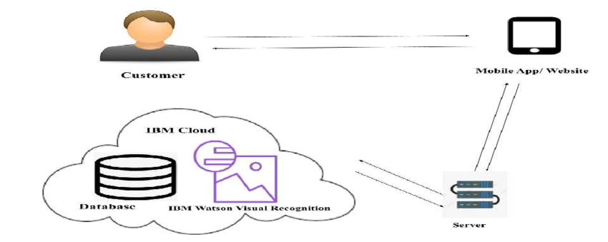

**APPROACHES :**

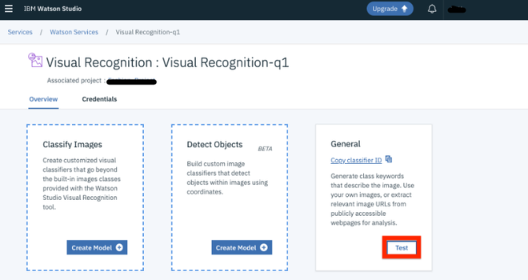

**FILTERED RESULTS :**

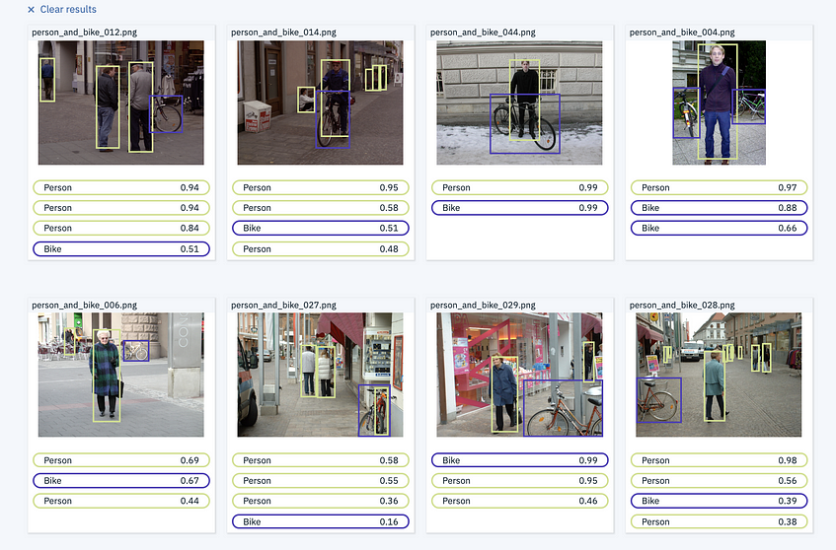

**PROCEDURE :**

1. **Create an IBM Cloud Account: If you don't already have one, sign up for an IBM Cloud account and log in.**
2. **Create a Visual Recognition Service Instance: Navigate to the IBM Cloud Dashboard and create a new instance of the Visual Recognition service.**
3. **Obtain API Credentials: After creating the service instance, obtain the API credentials (API key) necessary to authenticate your requests to the Visual Recognition service.**
4. **Prepare and Train Your Model: Gather a set of images that you want to use to train your model. Organize these images into classes or categories based on what you want the model to recognize.**
5. **Train the Model: Use the IBM Watson Visual Recognition API to upload and train your model using the prepared images and classes.**
6. **Use the Trained Model for Prediction: Once the model is trained, you can use it to predict or classify new images. You'll send an image to the API, and it will return the predicted class or classes for that image.**
7. **Integrate into Your Application: Implement the necessary code to call the Visual Recognition API with your images and handle the responses to make predictions within your application**
8. **Accuracy Optimize : The model to achieve a high accuracy rate in food classification and ensure efficient performance, even with a large number of images.Continuously monitor and evaluate the model's accuracy, making adjustments to improve its performance based on feedback and testing.**
9. **Optimize the model to handle image recognition tasks efficiently and maintain high accuracy, even with varying lighting conditions and image qualities.**

**10.User Engagement : Design features to allow users to share their enhanced images**

**CONCLUSION :**

**So we have a clear roadmap for developing an automated image recognition system using IBM Watson Visual Recognition. Each component focuses on specific aspects of the project, enabling efficient implementation and successful achievement of the overall project**

**PRESENTED BY**

**K.Dharani**

**S.Nivetha**

**T.Abirami**

**K.Pavithra**